Weird Geological Formations: What’s the Story?

There are some strange natural geological formations out there! Test your knowledge on what geological processes may have resulted in these structures on Earth’s surface. Match each image to the description that best explains its formation.

IMAGES

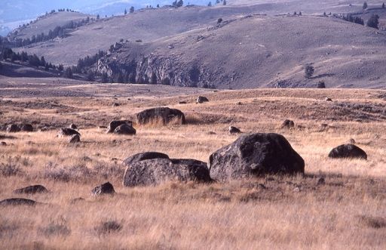  A | 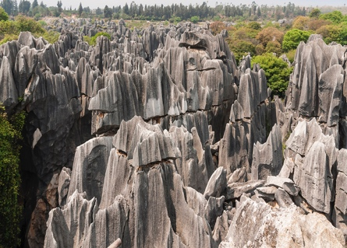  B | 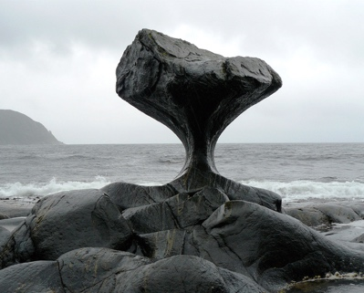  C
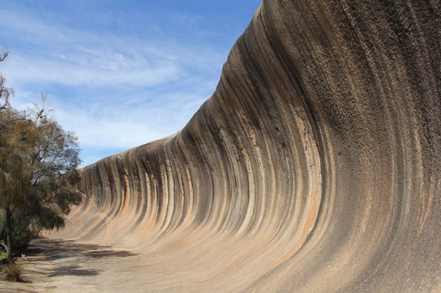  D | 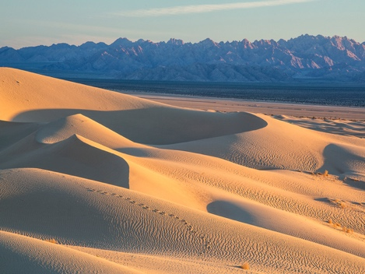  E | 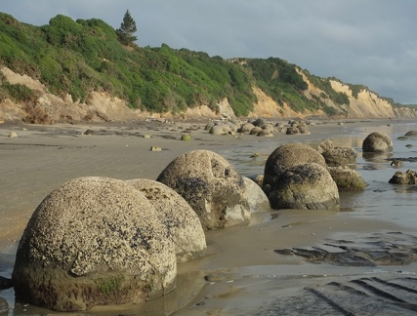  F

Image credits: ©1977, J. Schmidt/National Park Service; ©Photo by CEphoto, Uwe Aranas; Courtesy of Chell Hill; Courtesy of John Cooke; Photo by Bob Wick/Bureau of Land Management/U.S. Dept. of the Interior; Pseudopanax

DESCRIPTIONS

Write the letter of the corresponding image to the left of the description.

Letter | Description

Moeraki Boulders (Otago, New Zealand).
A concretion is a hard mass of minerals that forms in sedimentary rock when sediment builds up gradually around a nucleus, such as a grain of sand or piece of shell. Concretions are generally harder than the rock around them. Formed originally in soft mud on the seafloor some 60 million years ago, these giant concretions have been eroded by wave action and exposed over time.

Shilin Stone Forest (Kunming, China).
Covering a region that stretches hundreds of square kilometers, these limestone structures rise up to 30 meters (98 feet) tall. The limestone, which dissolves relatively easily in contact with slightly acidic rain and groundwater, left behind various shapes as the rock wore away and dissolved.

Glacial Erratics (Yellowstone National Park, Wyoming, US).
Carried by glaciers and then left stranded when the ice melted, these formations look out of place in their surroundings. Glacial erratics can be quite large, sometimes bigger than a house!

Sand Dunes (Sand to Snow National Monument, California, US).
Sand is moved by wind in different ways, depending on the size and weight of the grains. Crescent-shaped dunes form when the wind blows in one direction, with the gentle slope facing the wind; the “arms” point in the direction the wind is blowing. Dune shapes and patterns change constantly with altering wind conditions. When wind blows over sand from multiple directions, the resulting multiarmed dunes may even look like stars!

Wave Rock (Hyden, Australia).
This structure is part of a granite hill that dates back over 2.6 billion years. About 14 meters (46 feet) high and 110 meters (360 feet) long, it is a product of processes that exposed the once-buried granite bedrock. Through erosion, the top of the granite became exposed; as rainwater ran off and collected, intense weathering of the adjacent rock beneath surface resulted in the characteristic concave slope.

Kannesteinen Rock (Vågsøy, Norway).
This oddly shaped rock along the coast was sculpted over thousands of years as it weathered heavy winds and breaking waves. The top of the rock has been eroded less than the portion below it, resulting in its unusual shape.

©2017 WGBH Educational Foundation. All Rights Reserved.

